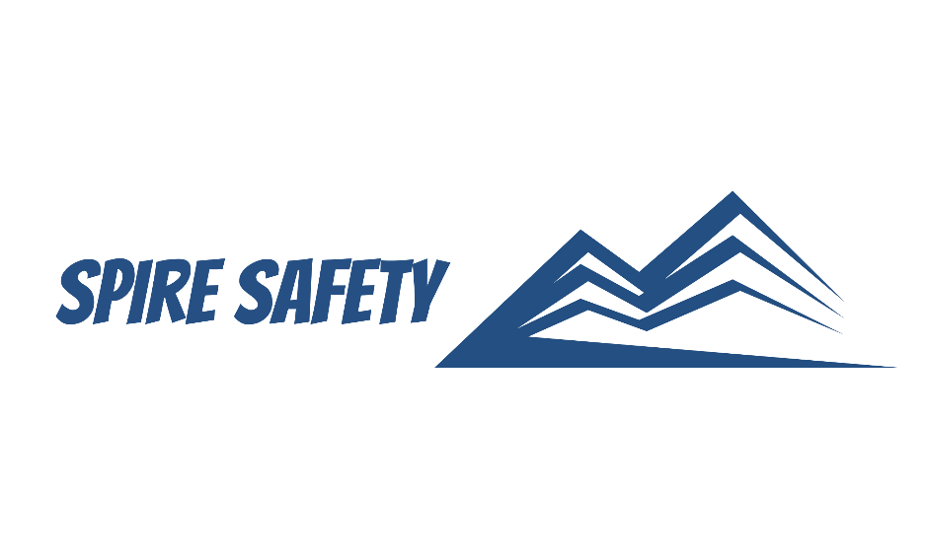
SS-WHS-PRO-000

COMMUNICATION AND CONSULTATION PROCEDURE

DOCUMENT HISTORY

rev | date | Description |  | approved by

Phone:
Email:
Address:
DISCLAIMER
While every effort has been made to ensure the accuracy, completeness, and reliability of the information presented, we make no representations or warranties of any kind, express or implied, regarding the content or suitability of this document for any particular purpose. The contents of this document are confidential, privileged, and provided expressly for intended recipients’ use only. This document may not be used, published, or redistributed without prior consent.

Contents
1 Purpose 3
2 Scope 3
3 Communication and Consultation Procedure 3
3.1 When Communication and Consultation is Required 3
3.2 Communication Channels 3
3.2 Consultation Topics 4
3.3 Consultation Methods 4
3.4 Ensuring Participation and Removing Barriers 4
3.5 Monitoring and Reviewing 5
4 Reference Documents 5

1 Purpose
The purpose of this Communication and Consultation Procedure is to establish a systematic approach for communication and consultation within our organisation. This procedure ensures effective two-way communication and meaningful consultation between all relevant parties to enhance WHS performance, promote employee participation, and facilitate continuous improvement.

2 Scope
This procedure applies to all employees, contractors, visitors, and any other relevant parties within the organisation and includes all works and facilities covered by the work health and safety management system.

3 Communication and Consultation Procedure

3.1 When Communication and Consultation is Required
Consultation and communication are undertaken whenever there is the requirement to share information with relevant stakeholders or to obtain information from them. Communication and consultation with stakeholders are required when:
- Identifying hazards and assessing WHS risks,
- Making decisions about ways to eliminate or minimise those risks,
- Making decisions about the adequacy of facilities for the welfare of workers,
- Proposing changes that may affect WHS performance,
- Making decisions about procedures for consulting with workers,
- Resolving WHS issues at the workplace, and
- Providing WHS information and training for workers.

3.2 Communication Channels
As our organisation committed to effective communication, we have established a diverse range of communication channels to facilitate the exchange of information and ideas regarding work health and safety standards. We recognise the importance of ensuring that all relevant parties can access and understand the information conveyed through these channels. Employees that require an official communication channel with internal and external stakeholders are provided company email accounts. Our email system allows for prompt dissemination of critical WHS information. Through this channel, we are able to communicate updates on policies, procedures, hazards, and controls directly to employees, contractors, and other interested parties.
Notice boards are strategically placed in common areas throughout the organisation to provide employees with access to vital information. These notice boards serve as a visible platform for sharing important announcements including:
- Policies and procedures (including those being reviewed),
- WHS alerts,
- First aid personnel, and
- Emergency response processes.
Recognising the importance of face-to-face interaction, we organise regular face-to-face forums where WHS information is a recurring agenda item. These forums provide a valuable platform for employees to voice their concerns, share suggestions, and engage in open discussions regarding safety, quality, or environmental matters. By fostering an environment of open dialogue, we encourage active participation and empower employees to contribute their ideas and expertise, ultimately strengthening our collective safety and high-quality standard efforts.

3.2 Consultation Topics
To identify consultation topics, we adopt a proactive and inclusive approach. We gather input from various sources, including employees, contractors, and relevant regulatory information. By involving a diverse range of perspectives, we aim to capture a comprehensive understanding of the WHS landscape within our organisation. These assessments identify potential safety hazards and environmental and quality risks and prioritise areas where consultation is most critical. We engage employees and their representatives in these risk and opportunity assessments, ensuring their invaluable insights are incorporated into the identification of consultation topics.
We also pay close attention to emerging work health and safety trends and developments within our industry. We stay updated on relevant legislation, regulations, and best practices to ensure our consultation topics align with the latest standards. This proactive approach allows us to address potential challenges and emerging risks promptly.

3.3 Consultation Methods
We understand that effective consultation methods are vital for engaging all relevant parties and fostering a culture of collaboration in WHS. We utilise various methods to ensure that our consultation efforts are meaningful, inclusive, and result oriented. One of the key factors in ensuring the effectiveness of our established communication methods is their accessibility. We strive to provide multiple channels that cater to different communication preferences and circumstances. These channels include:
- Face-to-face forums:
  - WHS Inductions,
  - WHS Review Meetings, and
  - Simultaneous operations (SIMOPS) meetings.
- Online platforms,
- Suggestion boxes, and
- Anonymous reporting mechanisms.
By offering diverse options, we enable individuals to choose the method that best suits their needs, thereby maximizing their participation and engagement.

3.4 Ensuring Participation and Removing Barriers
To ensure effective participation, we focus on eliminating barriers to consultation. We recognise that workers and subcontractors may face various challenges such as language barriers, cultural differences, or limited access to information. Therefore, we strive to provide accessible communication channels and materials in multiple languages. We actively encourage and facilitate the involvement of workers and subcontractors in consultation activities. We promote a culture of trust, respect, and open communication, ensuring that their opinions and perspectives are valued. To overcome any potential barriers related to hierarchy or fear of reprisal, we create a safe and supportive environment for workers and subcontractors to express their concerns, provide feedback, and contribute to the consultation process. We establish anonymous reporting mechanisms, such as suggestion boxes or confidential hotlines, to encourage individuals to share their thoughts without fear of retaliation.

3.5 Monitoring and Reviewing
The effectiveness of communication and consultation procedures is monitored and regularly reviewed during WHS meetings and Management Meetings.

4 Reference Documents
The following documents are referenced within this procedure:
- NA

