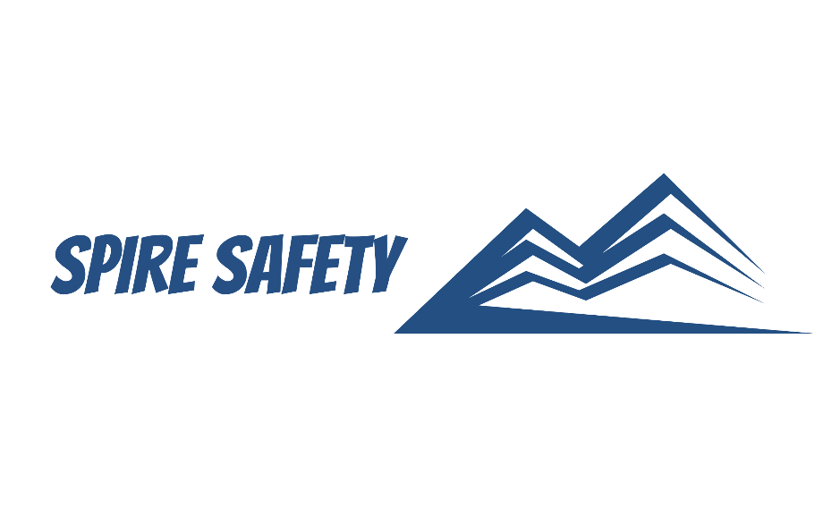

FATIGUE MANAGEMENT PROCEDURE
SS-WHS-PRO-000

DOCUMENT HISTORY

rev | date | Description |  | approved by

Phone:
Email:
Address:
DISCLAIMER
While every effort has been made to ensure the accuracy, completeness, and reliability of the information presented, we make no representations or warranties of any kind, express or implied, regarding the content or suitability of this document for any particular purpose. The contents of this document are confidential, privileged, and provided expressly for intended recipients’ use only. This document may not be used, published, or redistributed without prior consent.

Contents
1 Purpose 3
2 Scope 3
3 Identification of Fatigue Risks 3
4 Fatigue Management Strategies 3
4.1 Sufficient Breaks 3
4.2 Avoiding Night-Shift Arrangements 3
4.3 Managers Consider Fatigue When Planning 3
4.4 Ongoing, Open Dialogue with Workers 3
4.5 Job Rotation 4
4.6 Comfortable Work Environment with Adequate Welfare Facilities 4
5 Journey Management and Driving 4
4 Reference Documents 4

1 Purpose
The purpose of this Fatigue Management Procedure is to ensure the safety and well-being of employees and contractors by effectively managing and mitigating the risks associated with fatigue in the workplace.

2 Scope
This procedure applies to all employees and contractors involved in our work, regardless of position or contract type.

3 Identification of Fatigue Risks
We plan and review the tasks we perform as well as the working conditions to identify any factors that might be causing fatigue with particular focus given to known fatigue hazards, including:
- Driving,
- Shift work,
- Rosters, scheduling and overtime,
- Physically or mentally demanding tasks,
- Noisy, poorly lit, or improperly ventilated workspaces, and
- Insufficient staff levels.
We consult with our staff on these hazards and aim to develop strategies that minimise or eliminate the risk of fatigue.

4 Fatigue Management Strategies
We work with our staff and contractors to develop effective management strategies. Depending on the work task and situation, the following strategies may be used.

4.1 Sufficient Breaks
Regular breaks are essential for preventing fatigue, allowing individuals to recharge both mentally and physically. Breaks should be strategically incorporated into work schedules to optimise productivity and well-being.

4.2 Avoiding Night-Shift Arrangements
Limiting or avoiding night-shift arrangements, when feasible, contributes to preventing work-related fatigue. Night shifts can disrupt circadian rhythms and lead to increased fatigue levels, so this is to be avoided, if possible.

4.3 Managers Consider Fatigue When Planning
We implement a proactive approach to work scheduling that takes into account the potential for fatigue. Managers must be mindful of factors such as extended work hours, overtime, shift durations and travel that may contribute to fatigue.

4.4 Ongoing, Open Dialogue with Workers
Establishing and maintaining open communication channels with staff is essential for understanding their concerns and experiences. Regular dialogue, via safety meetings or other forums, allows for the identification of potential fatigue-related issues and provides an opportunity to collaboratively address and mitigate them.

4.5 Job Rotation
We introduce job rotation practices where feasible. This strategy helps distribute physical and mental demands, preventing monotony and reducing the risk of prolonged fatigue from repetitive tasks.

4.6 Comfortable Work Environment with Adequate Welfare Facilities
We aim to create a comfortable work environment that prioritises the well-being of employees to assist in managing fatigue. This includes providing adequate welfare facilities, comfortable rest areas, and amenities that support employee health and comfort.

5 Journey Management and Driving
We implement a simple, undocumented “Check-in System” for long journeys. This system requires workers to allocate rest breaks (maximum of 2 hours between rests) and to liaise with their supervisor to determine “check-in” times, whereby the worker will call the supervisor to confirm their safe arrival. Other strategies used to manage journey management and driving include:
- Ensuring vehicles are well maintained,
- Ensuring drivers are licenced,
- Ensuring no working day exceeds 12 hours (including travel),
- Training staff on how to identify and respond to fatigue while driving, including:
  - Avoiding caffeine,
  - Alerting supervisor if they feel the affects of fatigue, and
  - Pull over and rest, if needed.

4 Reference Documents
The following documents are referenced within this procedure:
- NA.

