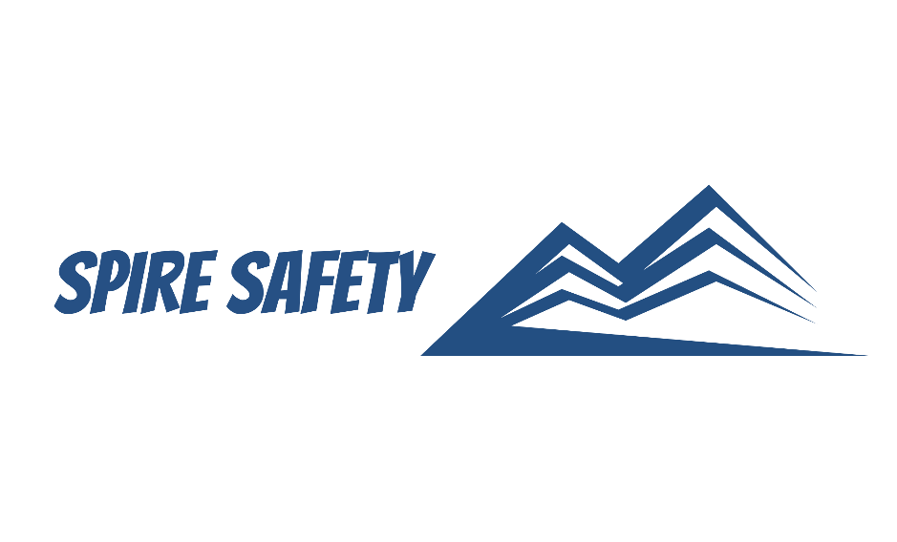

HAZARDOUS CHEMICALS PROCEDURE
SS-WHS-PRO-000

DOCUMENT HISTORY

rev | date | Description |  | approved by

Phone:
Email:
Address:
DISCLAIMER
While every effort has been made to ensure the accuracy, completeness, and reliability of the information presented, we make no representations or warranties of any kind, express or implied, regarding the content or suitability of this document for any particular purpose. The contents of this document are confidential, privileged, and provided expressly for intended recipients’ use only. This document may not be used, published, or redistributed without prior consent.

Contents
1 Purpose 3
2 Scope 3
3 Hazardous Chemicals Procedure 3
3.1 Risk Assessment and Procurement 3
3.2 Safe Handling and Storage 3
3.3 Disposal 4
3.4 Training and Competency 4
3.5 Health Monitoring 4
4 Reference Documents 4

1 Purpose
The purpose of this Hazardous Chemicals Procedure is to ensure the safe handling, storage, use, and disposal of hazardous substances within our organisation. This procedure aims to protect the health and safety of personnel, minimise the risk of accidents or incidents, reduce or eliminate environmental impacts, and ensure compliance with relevant regulations.

2 Scope
This procedure applies to all employees, contractors, and authorised personnel who handle, store, use, or come into contact with hazardous substances during their work activities.

3 Hazardous Chemicals Procedure

3.1 Risk Assessment and Procurement
We conduct a thorough review of our operations, and identified chemical hazards are listed within the risk management tools with the risks being assessed in accordance with the risk management procedures.
A risk assessment is conducted on “high-risk” or particularly hazardous chemicals with consideration given to evaluate the suitability and compatibility of the chemical with the intended tasks. The selection process considers factors such as:
- Chemical properties,
- Quantities,
- Storage requirements, and
- Potential health, safety, and environmental impacts.
All hazardous substances are listed within the SDS Register.

3.2 Safe Handling and Storage
Handling and storage of hazardous chemical is done in accordance with the relevant Safety Data Sheet. When handling chemicals, we ensure that:
- Hazardous chemicals are substituted with less harmful chemicals where possible,
- Engineering controls, such as fume hoods or protective barriers, are used where possible to minimise exposure during use,
- All personnel handling hazardous substances are trained on safe handling practices, including proper use of PPE,
- Hazardous substances are stored in designated areas with appropriate labelling, signage, and containment measures,
- Incompatible substances are segregated to prevent cross-reactions or reactions that may generate hazardous conditions,
- Control measures are implemented to minimise exposure, such as ventilation systems, local exhausts, and containment procedures, and
- Emergency procedures are in place, including firefighting equipment and spill kits.

3.3 Disposal
Before disposal, hazardous chemicals are identified and classified as hazardous waste based on their properties, composition, and potential impact on human health and the environment. This includes a comprehensive assessment of their toxicity, flammability, reactivity, and potential for environmental contamination. Hazardous waste is segregated and contained to prevent cross-contamination and minimise the risk of accidents or environmental harm.
Properly labelled and sealed containers are used to store different types of hazardous waste, ensuring compatibility and preventing leakage or spillage. We adhere to all applicable local, national, and state regulatory requirements for the disposal of hazardous waste.

3.4 Training and Competency
Training and competency requirements for hazardous chemicals are rigorously evaluated with identified training needs being addressed promptly. All training records are documented in the Training Register. Employees and contractors who use hazardous chemicals receive appropriate training on safe use, storage, disposal and emergency procedures.
Training for hazardous chemicals involves a thorough review of the Safety Data Sheets and the hazards and controls listed within. Competency assessments and refresher training are conducted regularly to ensure ongoing competency and adherence to safe work practices.

3.5 Health Monitoring
Health monitoring is conducted in accordance with the WHS Regulations, including any chemicals that are listed in Schedule 14 that pose serious risks to the health and safety of workers.

4 Reference Documents
The following documents are referenced within this procedure:
- NA

