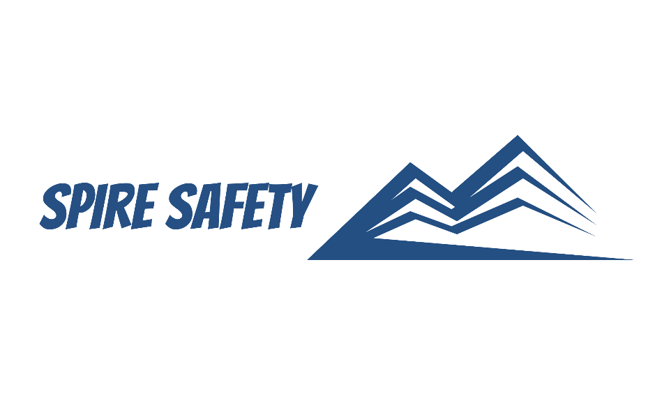
SS-WHS-PRO-000

HYGIENE AND WELFARE FACILITIES PROCEDURE

DOCUMENT HISTORY

rev | date | Description |  | approved by

Phone:
Email:
Address
DISCLAIMER
While every effort has been made to ensure the accuracy, completeness, and reliability of the information presented, we make no representations or warranties of any kind, express or implied, regarding the content or suitability of this document for any particular purpose. The contents of this document are confidential, privileged, and provided expressly for intended recipients’ use only. This document may not be used, published, or redistributed without prior consent.

Contents
1 Purpose 3
2 Scope 3
3 Hygiene and Welfare Facilities Procedure 3
3.1 Facilities Planning and Design 3
3.2 Sanitary Facilities 3
3.3 Personal Hygiene Facilities 3
3.4 Changing and Locker Facilities 3
3.5 Rest and Break Areas 3
3.6 Maintenance and Inspection 3
4 Reference Documents 3

1 Purpose
The purpose of this Hygiene and Welfare Facilities Procedure is to establish guidelines for the provision and maintenance of hygiene and welfare facilities within our organisation. These facilities aim to promote employee well-being, health, and comfort by providing clean, safe, and functional spaces.

2 Scope
This procedure applies to all employees, contractors, visitors, and other personnel within our organisation who utilise or interact with the hygiene and welfare facilities provided. It encompasses all facilities that contribute to hygiene, health, and well-being, including but not limited to sanitary facilities, personal hygiene areas, changing and locker facilities, and rest and break areas.

3 Hygiene and Welfare Facilities Procedure

3.1 Facilities Planning and Design
Facilities planning and design take into consideration the size of our workforce, the specific needs of employees, and applicable space requirements. We strive to create functional and accessible facilities that accommodate the needs of all individuals.

3.2 Sanitary Facilities
Sanitary facilities are maintained at a high level of cleanliness and hygiene. These facilities include toilets, handwashing stations, and sanitary waste disposal areas. Regular cleaning, restocking of supplies, and routine maintenance are conducted to ensure optimal sanitation.

3.3 Personal Hygiene Facilities
Designated areas for personal hygiene activities, such as handwashing and grooming, are provided. These areas are equipped with running water, soap, hand dryers or paper towels, and waste disposal bins.

3.4 Changing and Locker Facilities
Changing and locker facilities are available to employees who require them. These facilities provide secure storage for personal belongings and changing areas for employees who wear specialized work attire or engage in physical activities.

3.5 Rest and Break Areas
Rest and break areas are provided to give employees a space to relax and recharge. These areas are equipped with comfortable seating, tables, and amenities to create a comfortable and inviting environment.

3.6 Maintenance and Inspection
Regular maintenance and inspections are conducted to ensure the proper functioning and cleanliness of hygiene and welfare facilities. Maintenance tasks include repair of any defects, replacement of faulty equipment, and addressing any identified issues promptly.

4 Reference Documents
NA.

