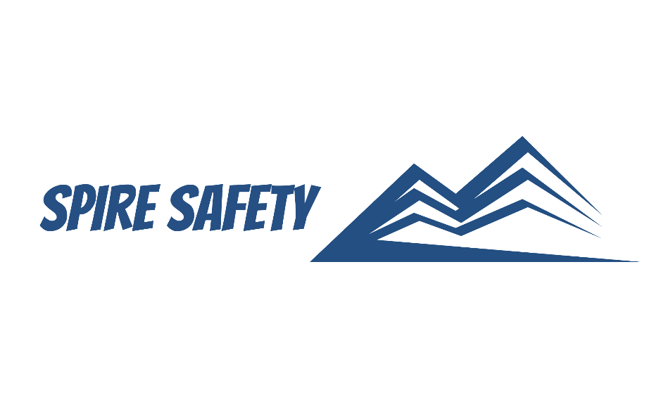
SS-WHS-PRO-000

MANUAL HANDLING PROCEDURE

DOCUMENT HISTORY

rev | date | Description |  | approved by

Phone:
Email:
Address:
DISCLAIMER
While every effort has been made to ensure the accuracy, completeness, and reliability of the information presented, we make no representations or warranties of any kind, express or implied, regarding the content or suitability of this document for any particular purpose. The contents of this document are confidential, privileged, and provided expressly for intended recipients’ use only. This document may not be used, published, or redistributed without prior consent.

Contents
1 Purpose 3
2 Scope 3
3 Manual Handling Procedure 3
3.1 Manual Handling Risk Assessments 3
3.2 Controlling Manual Handling Risks 3
3.2.1 Workplace Design and Ergonomics 3
3.2.2 Mechanical Aids and Equipment 4
3.2.3 Manual Handling Training 4
3.2.4 Lifting Technique 4
3.2.5 Carrying Technique 4
3.2.6 Lowering Technique 4
3.2.7 Pushing and Pulling Technique 4
3.2.8 Team Lifting Technique 5
3.3 Manual Handling Training 5
3.3.1 Importance of Manual Handling Training 5
3.3.2 Legal and Regulatory Framework 5
3.3.3 Hazards and Risk Assessment 5
3.3.4 Ergonomics and Body Mechanics 5
3.3.5 Safe Manual Handling Techniques 5
3.3.6 Use of Mechanical Aids and Equipment 5
3.3.7 Teamwork and Communication 6
3.3.8 Continuous Improvement and Reporting 6
4 Reference Documents 6

1 Purpose
The purpose of this Manual Handling Procedure is to establish guidelines and best practices for the safe and effective handling of objects and materials by individuals within our organisation. This procedure aims to prevent musculoskeletal injuries and promote a culture of safety when engaging in manual handling tasks.

2 Scope
This procedure applies to all employees, contractors, visitors, and any other relevant parties within the organization and includes all works and facilities covered by the work health and safety management system.

3 Manual Handling Procedure

3.1 Manual Handling Risk Assessments
We assess manual handling risks in accordance with our risk management procedures and include a wide range of considerations, including the weight, shape, and size of objects, as well as the physical capabilities of individuals involved in the manual handling tasks. We consider the characteristics of the work environment, such as space constraints, lighting conditions, and the presence of potential obstacles or hazards with particular attention given to activities that involve:
- Repetitive or sustained force,
- High or sudden force,
- Repetitive movement,
- Sustained or awkward posture, and
- Exposure to vibration.
Workers are consulted with during the risk assessment process and are given the opportunity to contribute ideas and possible controls to be implemented to manage the risks associated with manual handling.

3.2 Controlling Manual Handling Risks

3.2.1 Workplace Design and Ergonomics
In our organisation, workplace design and ergonomics are fundamental considerations in ensuring the well-being, comfort, and productivity of our workforce. We understand the importance of creating an environment that supports healthy postures, reduces the risk of musculoskeletal disorders, and enhances overall work performance.
Manual handling hazards are best eliminated at the design phase. Thus, where possible, during the design of our workplaces we take into consideration:
- Ergonomic workspace layout,
- Workstation configuration,
- Comfortable seating,
- Proper lighting,
- Ergonomic tools and equipment, and
- Accessible storage and organisation.

3.2.2 Mechanical Aids and Equipment
Whenever possible, mechanical aids and equipment are utilised to reduce the need for manual handling and minimise the risk of injury. We provide appropriate equipment such as trolleys, forklifts, or hoists to assist with lifting, carrying, and moving heavy or awkward objects.
PPE is also provided, including gloves and safety footwear to minimise the risk of injury.

3.2.3 Manual Handling Training
In our organisation, we prioritise the training and education of employees in a range of manual handling techniques to ensure safe and efficient execution of tasks. These techniques are designed to minimise the risk of musculoskeletal injuries and promote proper body mechanics during manual handling activities.

3.2.4 Lifting Technique
When lifting objects, we emphasise the following steps:
- Assessing the load,
- Standing close to the load,
- Adopting a stable base,
- Bending the knees keeping back straight,
- Maintaining a good grip,
- Lifting with legs, and
- Avoiding twisting.

3.2.5 Carrying Technique
When carrying objects, we promote the following techniques:
- Holding objects close to the body,
- Maintaining a neutral spine,
- Distributing the weight evenly, and
- Taking small steps.

3.2.6 Lowering Technique
When lowering objects to the ground or a lower level, we recommend the following steps:
- Planning the movement,
- Bending the knees,
- Controlling the descent, and
- Avoiding reaching or overreaching.

3.2.7 Pushing and Pulling Technique
When pushing or pulling objects, we emphasise the following guidelines:
- Assessing the weight and resistance,
- Maintaining a neutral spine,
- Using the body weight, and
- Using smooth and steady movements.

3.2.8 Team Lifting Technique
For objects that require multiple individuals to lift, we promote effective teamwork and coordination by:
- Communicating and planning,
- Maintaining a synchronised lift, and
- Having clear communication.

3.3 Manual Handling Training
Manual handling training is designed to equip individuals with the knowledge, skills, and awareness necessary to perform manual handling tasks safely and effectively. Our manual handling training program encompasses the following key elements.

3.3.1 Importance of Manual Handling Training
We emphasise the significance of manual handling training as a crucial component of our commitment to the health, safety, and well-being of our employees. Participants gain an understanding of the potential risks and consequences associated with improper manual handling practices, emphasising the need for proper training and adherence to safe handling techniques.

3.3.2 Legal and Regulatory Framework
We provide an overview of relevant legal requirements and regulations pertaining to manual handling. This includes an introduction to state work health and safety legislation, standards, and guidelines that govern manual handling practices. Participants gain insight into their rights and responsibilities.

3.3.3 Hazards and Risk Assessment
Training participants learn to identify and assess potential hazards associated with manual handling tasks. They gain an understanding of risk assessment techniques and the importance of proactive hazard identification. This enables individuals to recognise potential risks and take appropriate preventive measures to minimise the likelihood of injuries.

3.3.4 Ergonomics and Body Mechanics
We provide education on proper body mechanics and ergonomics to promote safe and efficient manual handling. Participants learn about maintaining neutral body positions, lifting and carrying techniques, pushing and pulling methods, and the importance of posture and balance during manual handling tasks. This knowledge empowers individuals to perform tasks with minimal strain and reduce the risk of musculoskeletal injuries.

3.3.5 Safe Manual Handling Techniques
We focus on teaching participants a range of safe manual handling techniques specific to their job roles and tasks. This includes lifting, lowering, carrying, pushing, and pulling techniques, considering factors such as load size, weight distribution, and environmental conditions. Practical demonstrations and hands-on exercises provide participants with opportunities to practice and refine their skills.

3.3.6 Use of Mechanical Aids and Equipment
We educate participants on the proper use of mechanical aids and equipment to assist with manual handling tasks. This includes instruction on selecting and using appropriate aids such as trolleys, dollies, or lifting devices. Participants gain an understanding of the benefits of utilising mechanical aids to reduce the risk of injury and improve efficiency.

3.3.7 Teamwork and Communication
We emphasise the importance of effective teamwork and communication during manual handling tasks. Participants learn how to coordinate and collaborate with others when lifting or moving heavy objects. They also gain insights into the significance of clear communication to ensure a safe and synchronised workflow.

3.3.8 Continuous Improvement and Reporting
We encourage participants to actively engage in the ongoing improvement of manual handling practices. They are encouraged to report hazards, near misses, and incidents related to manual handling to promote a culture of continuous learning and risk reduction.

4 Reference Documents
The following documents are referenced within this procedure:
- NA

