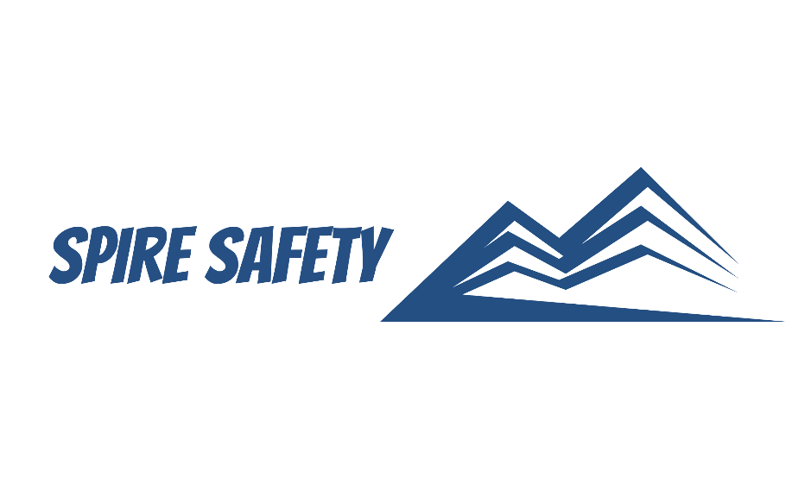

PERSONAL PROTECTIVE EQUIPMENT PROCEDURE
SS-WHS-PRO-000

DOCUMENT HISTORY

rev | date | Description |  | approved by

Copyright © 2023 Spire Safety Pty Ltd
Phone: 1300 156 382
Email: info@spiresafety.com.au
Address: 4/165 Stafford Road, Kedron Q 4031
DISCLAIMER
While every effort has been made to ensure the accuracy, completeness, and reliability of the information presented, we make no representations or warranties of any kind, express or implied, regarding the content or suitability of this document for any particular purpose. The contents of this document are confidential, privileged, and provided expressly for intended recipients’ use only. This document may not be used, published, or redistributed without prior consent.

Contents
1 Purpose 3
2 Scope 3
3 Personal Protective Equipment Procedure 3
3.1 Assessment of PPE Requirements 3
3.2 Procurement of PPE 3
3.3 PPE Training and Competency 3
3.4 PPE Issuing, Distribution and Storage 4
3.5 Fit Testing 4
3.6 Replacement and Disposal 4
4 Reference Documents 4

1 Purpose
The purpose of this Personal Protective Equipment Procedure is to establish a systematic approach for managing the personal protective equipment (PPE) requirements within our organisation.

2 Scope
This procedure applies to all employees, contractors, visitors, and any other relevant parties within the organisation and includes all works and facilities covered by the work health and safety management system.

3 Personal Protective Equipment Procedure

3.1 Assessment of PPE Requirements
We employ a comprehensive approach to identify and evaluate the potential hazards present in our work environment, including through the completion of the WHS Risk Register, WHS Inspections and Internal Audits. During these processes, we examine each task and job function to identify any potential hazards that cannot be eliminated through other control measures and thus will require PPE as a control measure.
Based on outcomes of the above processes, we carefully select the appropriate types of PPE that align with recognised standards and regulations. Our selection process considers various factors, including:
- Level of protection required,
- Compatibility with other safety equipment,
- Durability, and
- Wearer comfort.

3.2 Procurement of PPE
Procurement of PPE is managed in accordance with our internal procurement procedures and includes careful selection of suppliers based on their track record of producing reliable, certified, and compliant PPE that meets recognised industry standards. We prioritise suppliers who demonstrate a commitment to quality assurance, product testing, and adherence to relevant safety regulations.
Suppliers that pose significant risks to our WHS performance are required to complete the Supplier Pre-Qualification Checklist.
Suppliers of PPE are subject to ongoing evaluation via completion of the Supplier Evaluation Form.

3.3 PPE Training and Competency
PPE training encompasses the development of training programs that cover various aspects of PPE, including its purpose, selection, use, limitations, care, and maintenance. Initial familiarisation with PPE requirements is done during the WHS Induction. We provide regular refresher sessions to reinforce knowledge, address any updates or changes in PPE requirements, and promote continuous learning. These refresher sessions serve as opportunities to revisit important concepts, share best practices, and address any questions or concerns that may arise.

3.4 PPE Issuing, Distribution and Storage
We ensure that all issued PPE is appropriately identified, labelled, and stored in accordance with the manufacturer’s specifications. Each item bears clear markings, including identification tags that denote the type of PPE, size, and, when applicable, expiration dates. We prioritise prompt distribution of PPE to individuals based on their specific job roles and the hazards they face and ensure stock levels are maintained at adequate levels.
Workers are trained to conduct regular inspections, promptly report any issues, and seek replacements as needed, demonstrating their commitment to maintaining a high level of protection.

3.5 Fit Testing
Fit testing is a crucial aspect of our commitment to ensuring the utmost effectiveness and protection of PPE, particularly respiratory equipment. We recognise the importance of proper fit to ensure a secure seal and optimal performance of respiratory protection devices. Fit testing is conducted in accordance with established protocols, which may vary depending on the type of respiratory protection being used. The fit testing methods employed include qualitative fit testing and quantitative fit testing.
Fit testing sessions are conducted in controlled environments to minimise external factors that may affect the accuracy of the results. These sessions are conducted by skilled professionals who guide individuals through the testing process, ensure proper positioning of the respirator, and monitor the fit in real-time.

3.6 Replacement and Disposal
We encourage a proactive approach to identify and address damaged or worn-out PPE promptly. Individuals are responsible for inspecting their PPE regularly, looking for signs of wear, damage, or any deterioration that may affect its performance. If any issues are identified, individuals are required to report them immediately through designated channels. Upon receiving a report, our designated personnel assess the reported PPE to determine if replacement is necessary. If the PPE is deemed unsuitable for further use due to damage, wear, or exceeding its recommended service life, it is promptly replaced.
Used or expired PPE is collected and segregated in designated collection points or containers to ensure proper handling and prevent contamination of other waste streams. We educate and inform individuals about the importance of disposing of their used PPE in the designated collection areas to minimise environmental impacts. Once collected, the disposal process is carried out in accordance with applicable regulations and waste management protocols.

4 Reference Documents
The following documents are referenced within this procedure:
- NA

