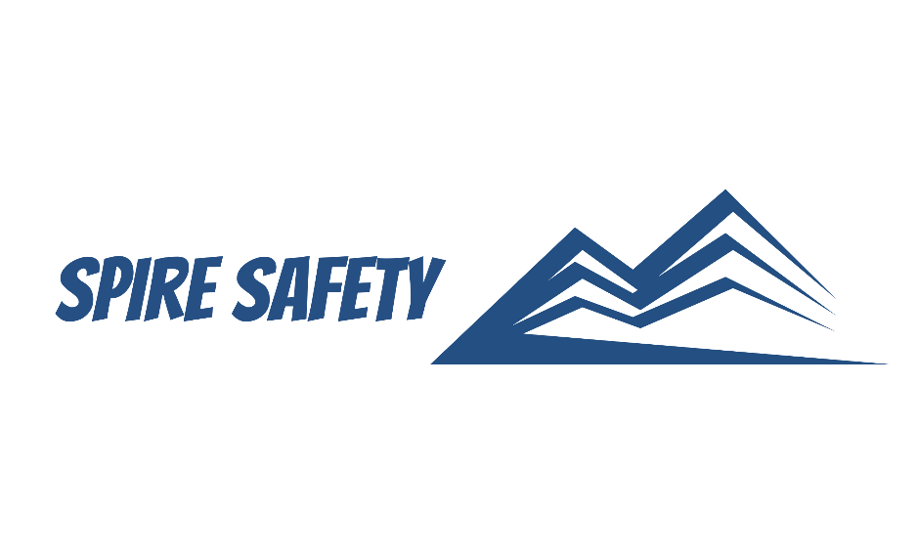

PLANT AND EQUIPMENT PROCEDURE
SS-WHS-PRO-000

DOCUMENT HISTORY

rev | date | Description |  | approved by

Phone:
Email:
Address:
DISCLAIMER
While every effort has been made to ensure the accuracy, completeness, and reliability of the information presented, we make no representations or warranties of any kind, express or implied, regarding the content or suitability of this document for any particular purpose. The contents of this document are confidential, privileged, and provided expressly for intended recipients’ use only. This document may not be used, published, or redistributed without prior consent.

Contents
1 Purpose 3
2 Scope 3
3 Plant and Equipment Procedure 3
3.1 Plant and Equipment (General) 3
3.1.1 Selection and Procurement 3
3.1.2 Training and Competency 3
3.1.3 Safe Operation 3
3.1.4 Maintenance and Fault Reporting 4
3.1.5 Lockout Tagout and Isolations 4
3.2 Electrical Testing and Tagging 4
3.3 Mobile Plant and Equipment 4
3.3.1 Safe Operation 4
3.3.2 Load Handling and Stability 5
3.3.3 Proximity Awareness and Hazard Identification 5
4 Reference Documents 5

1 Purpose
The purpose of this Plant and Equipment Procedure is to establish guidelines for the safe and efficient use, maintenance, and management of plant and equipment within our organisation. This procedure aims to ensure compliance with applicable regulations, promote workplace safety, and minimise the risk of accidents or incidents associated with plant and equipment.

2 Scope
This procedure applies to all employees, contractors, and authorised personnel who operate, maintain, or interact with plant and equipment within our organisation.

3 Plant and Equipment Procedure

3.1 Plant and Equipment (General)

3.1.1 Selection and Procurement
Plant and equipment procurement is done in accordance with internal procurement processes. A risk assessment is also completed in accordance with our risk management procedure with consideration given to evaluation of the suitability and compatibility of the equipment with the intended tasks. The selection process considers factors such as:
- Safety features,
- Maintenance requirements,
- Operator training, and
- Compliance with relevant standards and regulations.

3.1.2 Training and Competency
Training and competency requirements for plant and equipment are rigorously evaluated with identified training needs being addressed promptly. All training records are documented in the Training Register. Both employees and contractors who engage with plant and equipment undergo necessary training to ensure safe operation, maintenance, and understanding of emergency procedures.
Training programs are tailored to the specific type of equipment, its associated risks, and the individual's role and responsibilities. Competency assessments and refresher training are conducted regularly to ensure ongoing competency and adherence to safe work practices.

3.1.3 Safe Operation
All personnel operating plant or equipment are required to follow established safe work procedures. These procedures outline step-by-step instructions on the safe operation, start-up, shutdown, and maintenance of specific plant equipment.
Prior to operation, all equipment is subject to daily per-start inspections to identify faults and ensure the equipment is fit for purpose. Personnel operating plant or equipment are required to wear appropriate PPE based on the nature of the task and associated hazards. PPE may include items such as helmets, safety glasses, gloves, hearing protection, and protective clothing. Regular inspections and maintenance of PPE are carried out to ensure their effectiveness and compliance with relevant standards.

3.1.4 Maintenance and Fault Reporting
We implement a comprehensive preventive maintenance program for plant and equipment. This program includes regular inspections, servicing, and calibration of equipment based on manufacturer recommendations and industry best practices. We maintain detailed maintenance records that document the date, type of maintenance performed, and any identified issues or actions taken. These records provide an audit trail of maintenance activities and serve as a reference for future inspections and repairs. They also assist in tracking equipment performance and identifying recurring issues.
Prompt reporting of equipment faults is essential for timely resolution and minimising downtime. All personnel are encouraged to report any equipment malfunctions, abnormalities, or potential hazards immediately. Damaged equipment is isolated from use to prevent injury or damage due to its use.

3.1.5 Lockout Tagout and Isolations
Lockout, tagout and isolations is performed in accordance with SOP Lock-out Tag-out (LOTO) and includes the following steps:
- Shutting down the machinery and equipment,
- Identifying all energy sources and other hazards,
- Identifying all isolation points,
- Isolating all energy sources,
- Controlling or de-energising all stored energy,
- Locking out all isolation points,
- Tagging machinery controls, energy sources and other hazards, and
- Testing by ‘trying’ to reactivate the plant without exposing the tester or others to risk.
Employees involved in maintenance activities receive comprehensive training on the LOTO procedure, including the importance of following the process, identifying energy sources, and understanding the potential hazards.

3.2 Electrical Testing and Tagging
Equipment that is subject to testing and tagging is recorded in the Electrical Equipment Register. Testing is carried out in accordance with AS/NZS 3760:2022 In-service safety inspection and testing of electrical equipment and RCDs and is conducted by competent professionals with the relevant experience and qualifications. Frequency of inspections is outlined within the relevant Australian Standard.

3.3 Mobile Plant and Equipment

3.3.1 Safe Operation
Operators should adhere to safe movement guidelines when operating mobile plant equipment. This includes:
- Observing and following designated traffic routes and speed limits,
- Maintaining a safe distance from other mobile plant equipment, pedestrians, and fixed structures,
- Using signals, horns, or radios to communicate with other operators or personnel in the vicinity,
- Slowing down and exercising caution when approaching intersections, blind spots, or congested areas,
- Keeping a clear view of the path ahead, using mirrors and other available aids, and
- Being mindful of uneven surfaces, slopes, and changes in ground conditions.

3.3.2 Load Handling and Stability
When handling loads with mobile plant equipment, operators should adhere to safe load handling procedures:
- Ensuring loads are properly secured and balanced to prevent shifting or falling during movement,
- Following safe lifting and lowering techniques to avoid overloading the equipment or exceeding its rated capacity,
- Not exceeding the equipment's reach or height limitations,
- Taking extra precautions when handling bulky, unbalanced, or fragile loads, and
- Avoiding sudden starts, stops, or changes in direction to maintain load stability.

3.3.3 Proximity Awareness and Hazard Identification
Operators should maintain awareness of their surroundings and be vigilant for potential hazards. This includes:
- Regularly scanning the environment for pedestrians, other vehicles, and potential obstacles,
- Identifying and avoiding potential hazards such as overhead power lines, trenches, or unstable ground conditions, and
- Adhering to site-specific safety guidelines and protocols, including signage and barriers.

4 Reference Documents
The following documents are referenced within this procedure:
- NA

