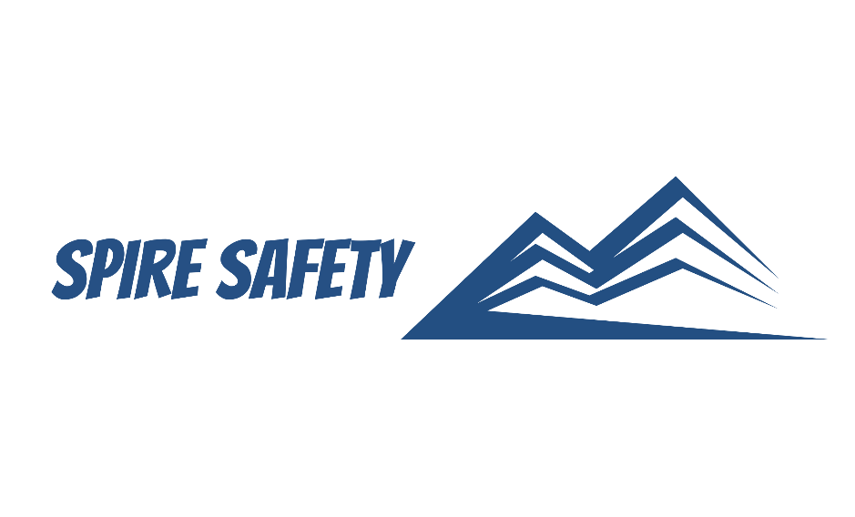
SS-WHS-PRO-000

PROCUREMENT AND CONTRACTOR MANAGEMENT PROCEDURE

DOCUMENT HISTORY

rev | date | Description |  | approved by

Copyright © 2023 Spire Safety Pty Ltd
Phone: 1300 156 382
Email: info@spiresafety.com.au
Address: 4/165 Stafford Road, Kedron Q 4031
DISCLAIMER
While every effort has been made to ensure the accuracy, completeness, and reliability of the information presented, we make no representations or warranties of any kind, express or implied, regarding the content or suitability of this document for any particular purpose. The contents of this document are confidential, privileged, and provided expressly for intended recipients’ use only. This document may not be used, published, or redistributed without prior consent.

Contents
1 Purpose 3
2 Scope 3
3 Procurement and Contractor Management Process 3
4 Procurement and Contractor Management Procedure 3
4.1 Procurement Risk Assessment 3
4.2 Supplier and Contractor Selection 5
4.3 Contractor Management 6
4.4 Ongoing Evaluation and Monitoring 7
5 Reference Documents 7

1 Purpose
This Procurement and Contractor Management Procedure outlines the steps and guidelines for procuring goods, services, and managing contractors within the framework of the WHS management system.
The purpose of this procedure is to ensure that all procurement activities and contractor engagements comply with relevant standards, legal requirements, and best practices.

2 Scope
This procedure applies to all procurement activities and contractor engagements related to the organisation's WHS management system, including the procurement of goods, services, and works, as well as the selection, evaluation, and management of contractors.

3 Procurement and Contractor Management Process

Diagram 3. Procurement and Contractor Management Process

4 Procurement and Contractor Management Procedure

4.1 Procurement Risk Assessment
Once procurement needs are identified, a risk assessment is performed on suppliers and contractors to identify the management actions required to mitigate risks. The procurement risk assessment is a systematic process used to identify, evaluate, and manage risks associated with the procurement of goods, services, or works for an organisation. It involves analysing potential risks throughout the procurement lifecycle, from planning and sourcing to contract management and supplier performance. The goal of procurement risk assessment is to identify and mitigate risks that may impact the organisation's ability to achieve its WHS objectives effectively.
The score is determined using a matrix that evaluates their risk and exposure levels.
Risk is categorised from 1 – 3, with the definitions presented in the table below.
Table 4.1-1. Risk Categories
Risk | Health and Safety Impact
1 | Workers not performing high risk activities (e.g., administrative workers)
2 | Workers performing high risk, routine tasks
3 | Workers performing high risk, non-routine tasks

Exposure is categorised 1 – 3, with the definitions presented in the table below.
Table 4.1-2. Exposure Categories
Exposure | Health and Safety Impact
1 | Workers spending short amounts of time on site (less than a day)
2 | Workers spending moderate amounts of time on site (multiple days or weeks)
3 | Workers routinely on site (months or years)

Once the Risk and Exposure have been identified, the following matrix is used to categorize the supplier or contractor:
 |  | EXPOSURE
 |  | 1 | 2 | 3
RISK | 1 | Low | Low | Low
RISK | 2 | Low | Medium | High
RISK | 3 | Medium | Medium | High

The outcome of the risk categorisation is used to guide the management of procurement of these goods and services. The following tables outline the management processes and controls required to manage the WHS risks posed by procurement activity. Note that flexibility is provided in the level of controls required by authorising relevant managers or supervisors to determine any potential requirements in addition to mandatory requirements.
Table 4.1-3. Risk Control Measures – Health and Safety Impacts
HEALTH AND SAFETY IMPACTS
Category | Management Process and Controls
Low | - Site Induction  - Any other requirements determined by the site manager or supervisor
Medium | - Site Induction  - Collection and review of documentation (e.g., SWMS, SOPs, licenses or tickets)  - Any other requirements determined by the site manager or supervisor
High | - Site Induction  - Completion of pre-qualification (SS-WHS-FOR-004 Supplier Pre-Qualification Checklist) and submission / review of relevant documentation  - Any other requirements determined by the site manager or supervisor

Significant risks identified are managed in accordance with the Risk Management Procedure (SS-WHS-PRO-001 Risk Management Procedure).

4.2 Supplier and Contractor Selection
We conduct a comprehensive and systematic search for potential suppliers and subcontractors, leveraging both traditional and innovative approaches. We utilise a diverse range of resources, including market research, industry databases, professional networks, and recommendations from trusted sources. The specific requirements for suppliers and subcontractors are determined based on organisational or project requirements. This includes identifying the products, services, or processes to be outsourced.
Evaluation criteria are established that align with the organisation or project’s needs, client specifications as well as any legal compliance requirements. These criteria may include factors such as:
- Safety record (including incidents and infringements),
- Compliance with legal requirements,
- Financial stability,
- Experience,
- Reputation, and
- Capacity.
In relation to contractor engagement, contractors should as a minimum demonstrate the following:
- Comprehensive knowledge of hazards and risks pertaining to the project's scope,
- Valid licenses, certificates, and relevant trade qualifications (where applicable),
- Maintenance of records and registrations for plant and equipment,
- Proficiency in conducting risk assessments for the specific tasks at hand,
- Up-to-date insurance coverage for Workers Compensation, Public Liability, and Professional Indemnity,
- Contractor, employees, and subcontractors have undergone suitable training for the work or activities involved, and
- Compliance with legislative requirements, such as safe work method statements for high-risk tasks.
Pre-qualifications (SS-WHS-FOR-004 Supplier Pre-Qualification Checklist) outline the requirements that suppliers and subcontractors must meet prior to engagement. Suppliers and subcontractors are required to complete a self-assessment questionnaire and provide relevant documentation to demonstrate their compliance with the pre-qualification criteria. This may include:
- Certifications,
- Policies,
- Procedures,
- Past performance records,
- Financial statements, and
- Other supporting documents.
The submitted documentation is reviewed and evaluated to assess the supplier or subcontractor's compliance with the pre-qualification criteria and the WHS management system requirements. This evaluation may involve verifying the validity of certifications, examining the adequacy of documented processes, and assessing the alignment with relevant standards.

4.3 Contractor Management
For low-risk contractors, ongoing engagement and management of the contractors’ activities can be done in line with the WHS management system. These contractors may be required to comply with various internal requirements, including:
- Completion of inductions,
- Supply of certifications / qualifications,
- Completing and signing on to JSAs, SWMS, permits or other risk management tools, and
- Any other requirement outlined within this WHS management system.
Medium or high-risk contractors will likely operate under their own system and will be subject to ongoing performance evaluation and monitoring, including:
- WHS inspections (SS-WHS-FOR-010 WHS Inspection),
- Internal audits (SS-WHS-FOR-012 Internal Audit), and
- WHS reporting and statistics (SS-WHS-REG-004 WHS Statistics Register).
Consultation and communication between contractors will be conducted routinely in line with project specific requirements and may involve contractor attendance at meetings, including:
- Pre-start safety meetings,
- Toolbox talks, and
- SIMOPs meetings.
High-risk contractors or contractors who wish to operate under their own WHS systems will be managed in accordance with this procedure to ensure compliance with the relevant WHS standards.
Contractors are made aware of WHS requirements either via email correspondence or in services agreements / contracts. Requirements placed on contractors may include:
- Communication, consultation, and cooperation, including their participation in:
  - Pre-start meetings,
  - Toolbox talks,
  - Other planning / WHS meetings as required,
- Simultaneous operations, including participation in SIMOPs meetings and SIMOPs risk assessment / control workshops,
- Incident reporting and notification requirements (SS-WHS-FOR-011 Incident Report and Investigation).
It is expected that contractors will comply with all relevant work health and safety legislation, codes and standards and contractors will be subject to ongoing performance monitoring and measuring activities, including:
- Collection of WHS Statistics (SS-WHS-REG-004 WHS Statistics Register),
- WHS Inspections (SS-WHS-FOR-010 WHS Inspection),
- Internal Audits (SS-WHS-FOR-012 Internal Audit),
- WHS Review Meetings (SS-WHS-FOR-007 WHS Review Meeting), and
- Management Review Meetings (SS-WHS-FOR-008 Management Review Meeting).

4.4 Ongoing Evaluation and Monitoring
Clear contractual requirements are defined and communicated to suppliers and contractors, specifying health and safety expectations, as well as compliance with the safety management system standards. Clauses in contracts are used to ensure adherence to organisational policies and procedures, reporting requirements, and provision of necessary resources.
Evaluation criteria and metrics are defined and communicated, such as:
- Quality performance,
- Delivery performance,
- Health and safety compliance, and
- Adherence to contractual obligations and WHS management system requirements.
Supplier and contractor performance is then periodically assessed using methods such as:
- WHS inspections (SS-WHS-FOR-010 WHS Inspection),
- Internal audits (SS-WHS-FOR-012 Internal Audit),
- Supplier Evaluations (SS-WHS-FOR-005 Supplier Evaluation Form),
- Site visits,
- Documentation reviews, and
- Feedback from internal stakeholders.

5 Reference Documents
The following documents are referenced within this procedure:
- SS-WHS-PRO-001 Risk Management Procedure
- SS-WHS-REG-004 WHS Statistics Register,
- SS-WHS-FOR-004 Supplier Pre-Qualification Checklist,
- SS-WHS-FOR-005 Supplier Evaluation Form,
- SS-WHS-FOR-007 WHS Review Meeting,
- SS-WHS-FOR-008 Management Review Meeting,
- SS-WHS-FOR-010 WHS Inspection,
- SS-WHS-FOR-011 Incident Report and Investigation, and
- SS-WHS-FOR-012 Internal Audit.

