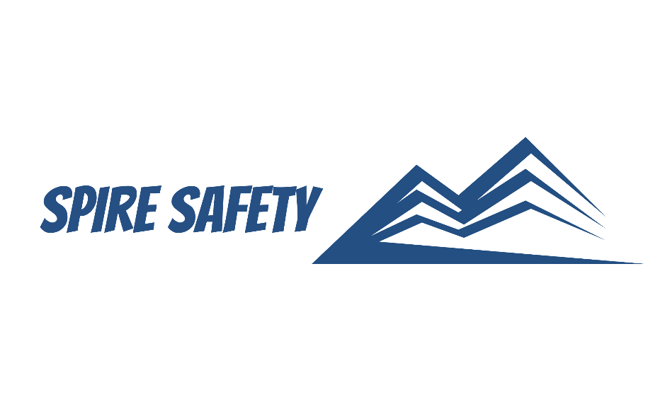

SS-WHS-PLA-000

SEXUAL & GENDER-BASED HARASSMENT PREVENTION PLAN
DOCUMENT HISTORY

rev | date | Description | approved by

Copyright © Company Name
Phone:
Email:
Address:

DISCLAIMER
While every effort has been made to ensure the accuracy, completeness, and reliability of the information presented, we make no representations or warranties of any kind, express or implied, regarding the content or suitability of this document for any particular purpose. The contents of this document are confidential, privileged, and provided expressly for intended recipients’ use only. This document may not be used, published, or redistributed without prior consent.

Contents
1 Purpose 4
2 Scope 4
3 Harassment Prevention Procedure 4
3.1 Identified Risks and Control Measures 4
3.1.1 Risks Identified and Controls 4
3.2 Consultation Undertaken 4
3.3 Procedures for Reporting and Responding to Harassment 5
3.4 Training, Awareness, and Access 5
4 Reference Documents 5

1 Purpose
The purpose of this harassment prevention procedure is to establish guidelines and practices for managing the risks of harassment, including sexual and gender-based harassment, in our workplaces. This procedure focuses on both proactive prevention and effective response.

2 Scope
This procedure applies to all employees, contractors and personnel who perform tasks or activities within our organisation. It applies at all times while performing work, attending work-related events, or representing the organisation.

3 Harassment Prevention Procedure

3.1 Identified Risks and Control Measures

3.1.1 Risks Identified and Controls
Risk # | Risk | Controls
Risk 1 | Isolated or unsupervised work environments | Buddy systems; avoid solo shifts; improve lighting and supervision
Risk 2 | Power imbalances (e.g. manager-subordinate) | Implement regular leadership training on ethical conduct and boundaries
Risk 3 | Gendered workplace culture or attitudes | Workshops or internal training on respectful behaviours; communicate zero tolerance policy
Risk 4 | Inadequate or unclear reporting systems | Anonymous and accessible reporting channels; assign a trained SGBH officer
Risk 5 | Lack of training on respectful behaviour | Mandatory induction and refresher training on harassment and respectful conduct
Risk 6 | Understaffing, long hours, high workload | Review of rosters and workload balance; introduce regular wellbeing check-ins

It is determined that a Moderate Risk Level exists. This risk rating considers:
- The potential severity of harm from harassment (psychological injury, career harm)
- The duration and frequency of potential harassment
- The likelihood of harassment occurring in identified settings
- Availability and suitability of existing control measures
IT also takes into consideration workplace specific factors, including:
- The layout and security of the physical work environment (e.g. private rooms, night shifts)
- The design and management of work (e.g. authority structures, work demands)
- Systems of work and communication (e.g. clarity of reporting processes)
- Training, information, and supervision adequacy
- Workplace culture and leadership behaviours

3.2 Consultation Undertaken
The following consultation must be undertaken with workers:
- Consultation was undertaken with workers during toolbox talks, staff meetings, and via an anonymous survey during the risk assessment process.
- Feedback from health and safety representatives (HSRs) and the WHS Committee was sought on risks and proposed control measures.
- Workers were invited to participate in the development of reporting procedures and prevention training.

3.3 Procedures for Reporting and Responding to Harassment
How a Person May Make a Report
- Verbally or in writing to their supervisor, HR, or designated SGBH Officer
- Anonymously
- Through a health and safety representative
How Reports Will Be Investigated
- Promptly and confidentially investigated within 5 working days
- Conducted in a trauma-informed, impartial, and procedurally fair manner
Representation
- Any person making a report may choose to be supported or represented by a representative of their choice (e.g. union, colleague, legal support)
Communication of Investigation Outcomes
- The reporting person and relevant parties will be informed of the outcome and any resulting actions, to the extent legally appropriate
Additional Options
- The reporting person may also initiate:
- Issue resolution under WHS Act Division 5
- Dispute resolution under WHS Act Division 7A
- External complaints via the Fair Work Ombudsman or AHRC

3.4 Training, Awareness, and Access
- All workers receive training at induction and annually
- Training includes rights, responsibilities, how to report, and bystander action
- Copies of this plan are:
  - Published on the internal staff portal and shared via email
  - Available in printed format in communal areas and on request
  - Explained during WHS induction and leadership meetings

4 Reference Documents
The following documents are referenced within this procedure:
- Document 1
- Document 2

