EQUIPMENT DESCRIPTION | Roller |  | 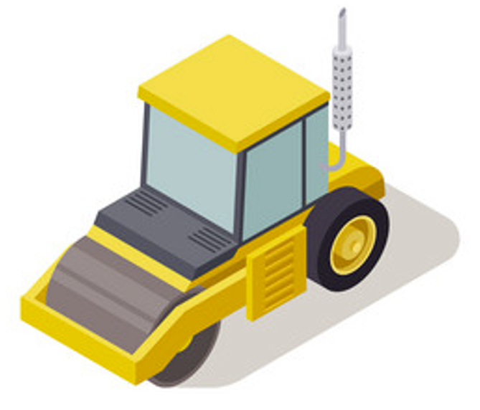
EQUIPMENT USED FOR
MAKE
MODEL
ASSESSED BY
DATE OF ASSESSMENT
CRITERIA |  | Y / N |  | L(I) | C(I) | R(I) | RECOMMENDED CONTROLS | L(R) | C(R) | R(R)
1. Can a person’s hair, clothing, gloves, necktie, jewellery, cleaning brush or rag become entangled with moving parts of the plant?
2. Can anyone be crushed due to:
- material falling off the plant?
- uncontrolled or unexpected movement of the plant?
- lack of capacity for the plant to be slowed, stopped or immobilised?
- the plant tipping or rolling over?
- parts of the plant collapsing?
- coming into contact with moving parts of the plant during testing, inspection, operation, maintenance, cleaning or repair?
- being thrown off or under plant?
- being trapped between the plant and materials or fixed structures?
- other factors not mentioned?
3. Can anyone be stabbed or punctured due to:
- coming in contact with sharp or flying objects?
- coming in contact with moving parts during testing, inspection, operation, maintenance, cleaning or repair?
- the plant, parts of the plant or work pieces disintegrating?
- work pieces being ejected?
- the mobility of the plant?
- uncontrolled or unexpected movement of the plant?
- other factors not mentioned?
4. Can anyone’s body parts be sheared between two parts of the plant, or between a part of the plant and a work piece or structure?
5. Can anyone be struck by moving objects due to:
- uncontrolled or unexpected movement of the plant or material handled by the plant?
- the plant, parts of the plant or work pieces disintegrating?
- work pieces being ejected?
- mobility of the plant?
- other factors not mentioned?
6. Can anyone come into contact with fluids under high pressure, due to plant failure or misuse of the plant?
7. Can anyone be injured by electrical shock or burnt due to:
- the plant contacting live electrical conductors?
- the plant working in close proximity to electrical conductors?
- overload of electrical circuits?
- damaged or poorly maintained electrical leads and cables?
- damaged electrical switches?
- water near electrical equipment?
- lack of isolation procedures?
- other factors not mentioned?
8. Can anyone be injured by explosion of gases, vapours, liquids, dusts or other substances, triggered by the operation of the plant or by material handled by the plant?
9. Can anyone be injured due to:
- poorly designed seating?
- poorly designed operator controls?
- high forces?
- awkward body posture or the need for excessive effort?
- repetitive movements?
- vibration?
- other factors not mentioned?
Can anyone be injured due to unexpected start-up, unexpected over-run/over-speed (or similar malfunction) from:
- failure/disorder of the control system, for example a hydraulic system?
- restoration of energy supply after an interruption?
- external influences on electrical equipment?
- other environmental factors (gravity, wind, etc.)?
- errors in the software?
- errors made by the operator?
Can anyone be injured due to:
- noise?
- inadequate or poorly placed lighting?
- entry into any confined spaces of the plant?
- failure to select plant that is suitable for its intended use?
- contact with hot or cold parts of plant?
- exposure to hazardous chemicals, radiation or other emissions released by the plant?
- lack of operator competency?
- other factors not mentioned?
- restricted vision due to seating position?

Risk Matrix |  | Consequences
 |  | Negligible (1)  Minimal injuries / no injuries | Minor (2)  Minor injuries / first aid | Significant (3)  Moderate injuries / medical treatment | Severe (4)  Serious injuries / hospitalisation | Catastrophic (5)  Death / permanent impairment
Likelihood | Certain (5)  100% likely / almost 100% likely | Moderate (5) | High (10) | High (15) | Catastrophic (20) | Catastrophic (25)
Likelihood | Likely (4)  Will probably happen / is likely to happen | Moderate (4) | Moderate (8) | High (12) | Catastrophic (16) | Catastrophic (20)
Likelihood | Possible (3)  Could happen or plausible | Low (3) | Moderate (6) | Moderate (9) | High (12) | High (15)
Likelihood | Unlikely (2)  Improbable but could happen / not expected | Low (2) | Moderate (4) | Moderate (6) | Moderate (8) | High (10)
Likelihood | Very Unlikely (1)  Rare / not expected but remotely possible | Low (1) | Low (2) | Low (3) | Moderate (4) | Moderate (5)

