TOPIC | Ladder Safety
SITE / PROJECT
SUPERVISOR |  |  | DATE
Background:  - Ladders are common tools we use every day, but it's essential to use them safely to avoid injuries.  - In Australia, we have rules and guidelines to make sure we stay safe when working with ladders.  - Most ladder accidents happen because of simple mistakes or not using ladders the right way. |  |  | 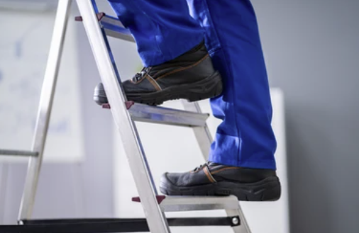
Hazards and common issues:  - Make sure the ladder is the right size for the job.  - Check that it can hold your weight and the weight of tools.  - Place the ladder on a flat and stable surface.  - Avoid using ladders on slippery or uneven ground.  - For extension ladders, make sure they are fully extended and locked in place.  - Don't stretch too far to the side—move the ladder instead.  - Always keep your belly button between the ladder's sides. |  |  | 
Safety controls:  - Check the ladder for any damage before use.  - Report any broken or wobbly parts immediately.  - Always have three points of contact—two hands and a foot or two feet and a hand—when climbing.  - Face the ladder and climb using both hands and feet.  - Don't carry heavy tools while climbing; use a tool belt or rope.  - Be cautious in windy or rainy weather.  - If it's too windy or wet, it's safer to delay the job. |  |  | 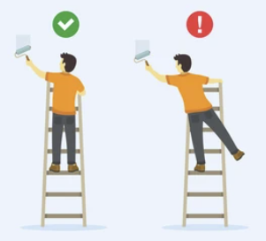
Feedback from staff or notes:
SIGNOFF
Name and Signature |  | Name and Signature

